

Faculty of Language Studies
EL111
TMA
2020-2021 /Summer
20 – October – 2021
Sessions
1312/1313/1314/1315/1316/1317/1318/1319/1320/1321/1322 هام
في حالة قيام الطالب/ة بالاختبار في غير يومه وغير شعبته يخسر درجة الاختبار (20 درجة )
في حالة تشابه مقالين لطالبين واكثر يخسر الطالبان درجات المقال (15)
في حالة النقل من الانترنت يخسر الطالب درجات اختبار المقال (15 درجة)
Time Allowed: 120 Minutes ( 2 Hours)

Instructions:
- You will download a file through a link on LMS.
- When you finish answering, you will have to upload the file again through the same link.
Marker's Initials & Signature | Earned Mark | Mark allocated | Question Number
 |  | 5 | Section I: Error-detecting & Correcting
 |  | 15 | Section II: Essay Writing
 |  | 20 | Total
....................................... |  |  | Student’s Name
......................................... |  |  | Student’s ID
........................................ |  |  | Student’s Session Number
- Please note that similarities in the essay with other students will get you a zero.
- Please note that taking the essay from the internet will get you a zero too.

Section | 1 | Editing | 5 Points
The following passage has 10 errors (mistakes) and it needs editing. Please fill out the below table with the errors, their types and corrections. The errors can be
- Grammar
- Spelling
- Punctuation
- Capitalization
- Indentation
- Wrong choice of words
- Wrong pronoun reference
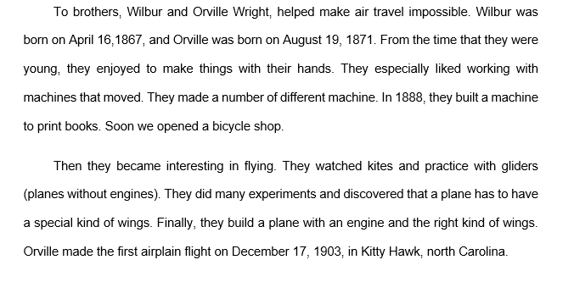.

# | Error | Paragraph # | Correction | Error Type
1
2
3
4
4
6
7
8
9
10

Go to the essay question below

Section | 2 | Essay Writing | 15 Points

Write an essay on only one of the following topics

- Living in big cities has a lot of advantages, but there are disadvantages too. Write an essay of not less than 200 words about your city /town mentioning in the process what you consider disadvantages in there.
Please note that copying from the interent will cost you 15 marks.

- In an essay of not less than 200 words, write why some people believe that studying English in an English speaking country is better than studying the language at a local school or colleage.
Please note that copying from the interent will cost you 15 marks.

Write your essay below

Teacher’s Use Only
Essay Grading Criteria
Proper Essay Division | Relevance | Proper Idea Development | Grammar | Spelling | Punctuation | Transition words & Phrases
2 | 2 | 3 | 3 | 1 | 3 | 1

